Abstract format: including figures and references.

Please follow the model below.

Quasi-reversible Electrochemical Reduction of …Full Title (Arial 11 Bold)

Presenting Authorª, Co-Authors1ª , Co-Authors1^{b} (Times New Romar 11)

- Organization, Address, City, Country(Times New Romar 11 Tilt)
- Organization, Address, City, Country(Times New Romar 11 Tilt)
E-mail: (Times New Romar 11)

Abstract (Times New Romar 11 Bold)

Electrochemical reduction of 2-ethylanthraquinone (EAQ) is a reaction of prime importance in view of its industrial application in electro-synthesis of hydrogen peroxide. However, the insolubility…(Times New Romar 11)

Figures

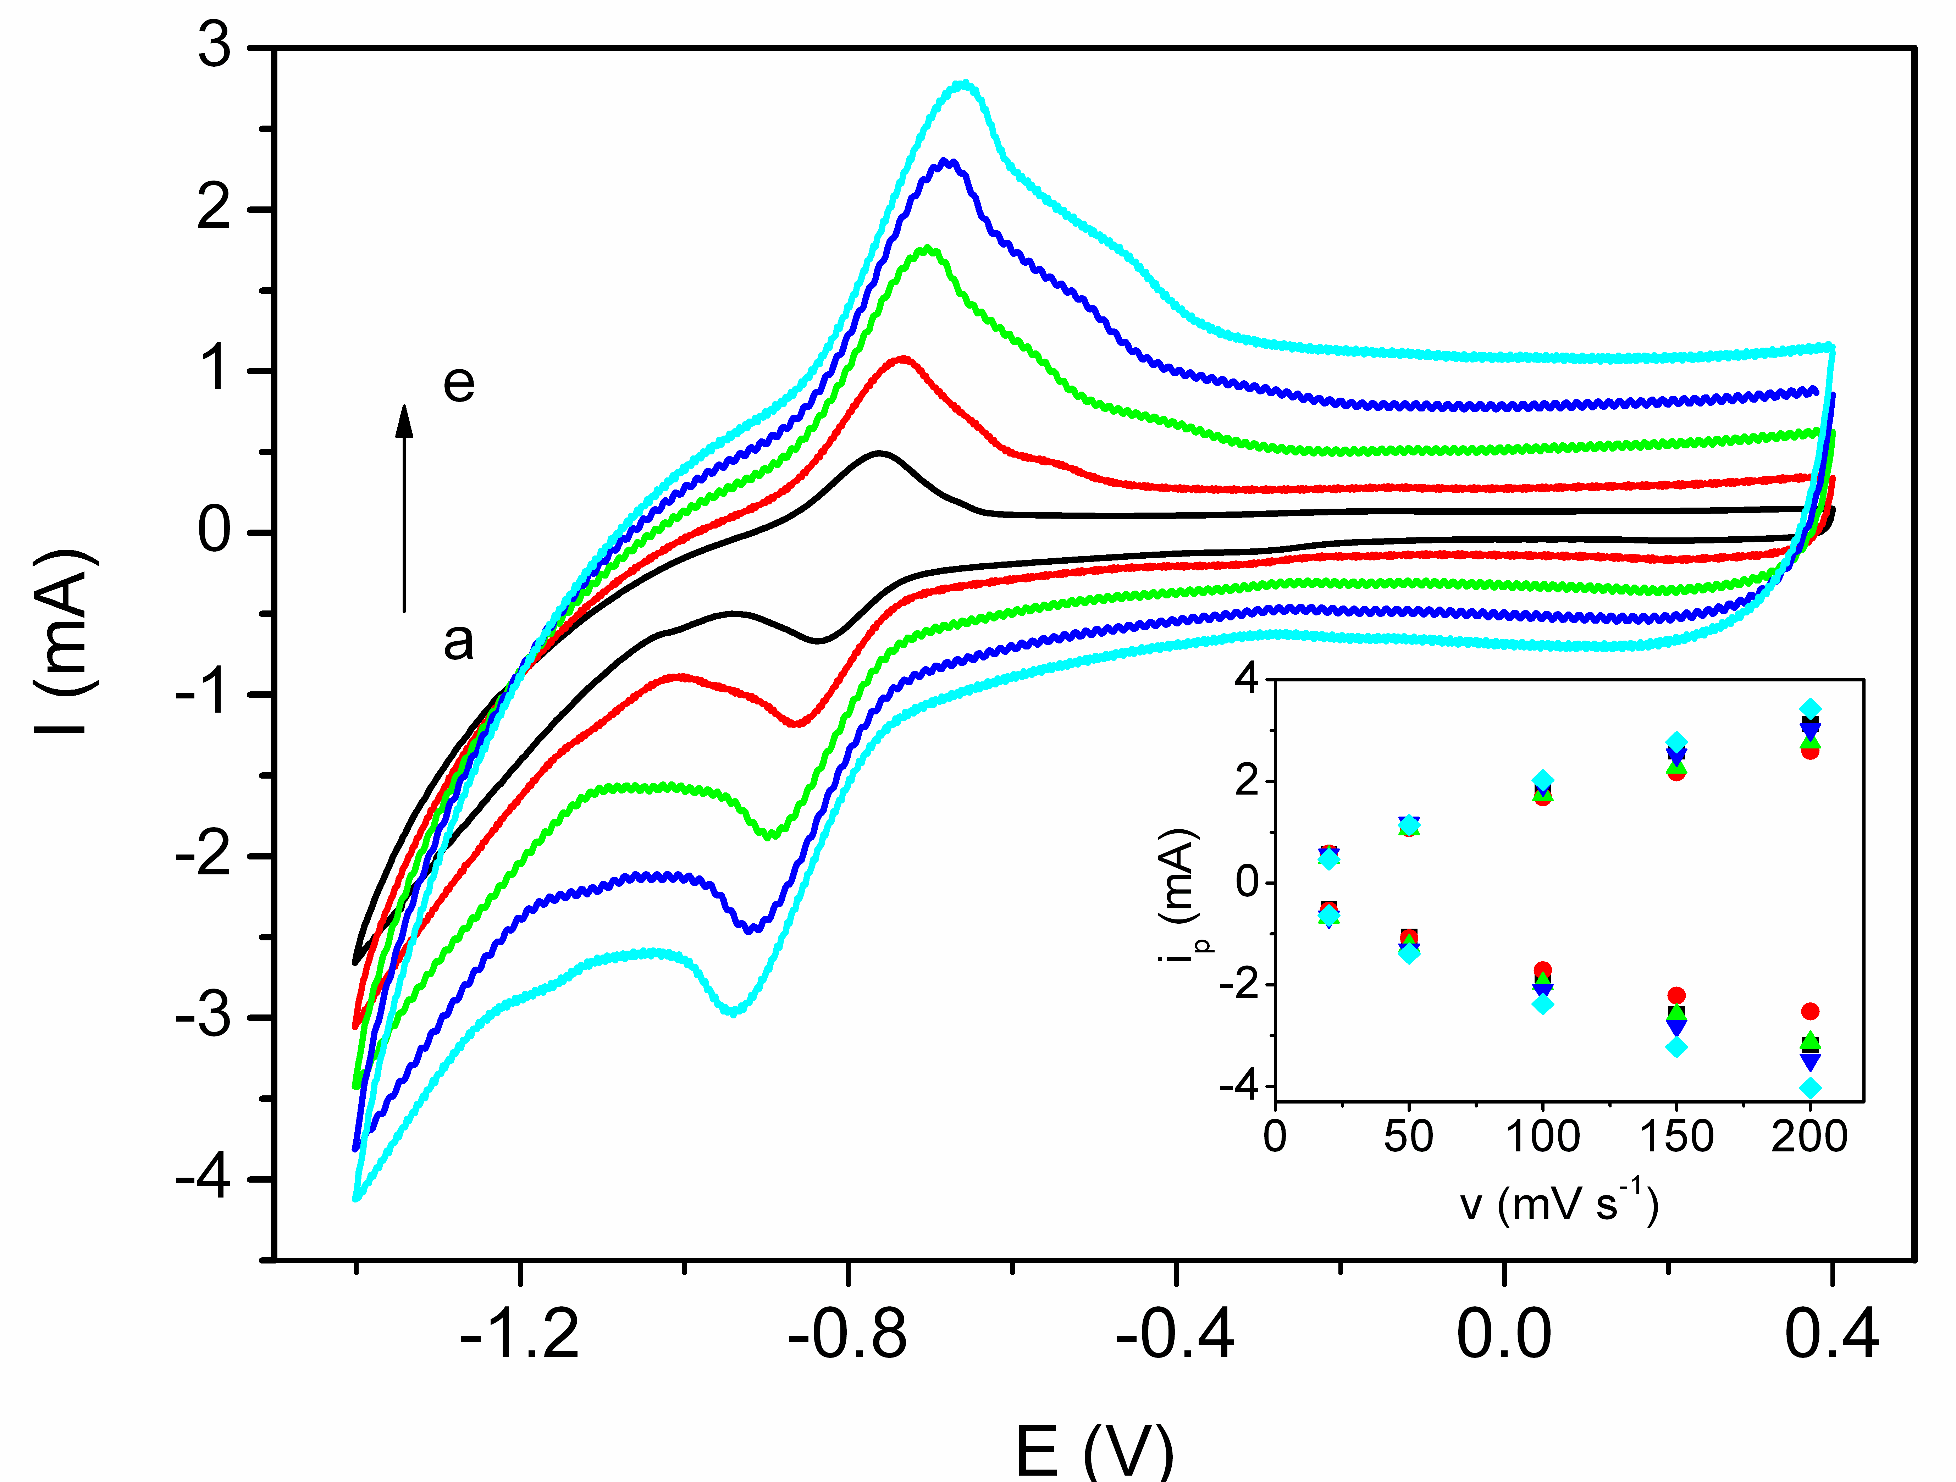
Fig. 1. CVs of the EAQ/PC in pH 5.63 O₂-saturated aqueous solution at various scan rates: (a) 20mVs⁻¹, (b) 50mVs⁻¹, (c) 100mVs⁻¹, (d) 150mVs⁻¹, (e) 200mVs⁻¹. Inset shows plots of i_{p} (EAQ electroreduction) vs. v obtained from CVs in various pH solutions: (■) 0.50, (●) 1.25, (▲) 5.63, (▼) 12.26 and (◆) 13.11, respectively.

References (Times New Romar 11 Bold)

[1] Authors, Journal, Issue (Year) page. (Times New Romar 10)

